浙大城市学院实验报告
课程名称 计算机网络实验
实验项目名称 实验5 三层交换机配置
学生姓名 司晨旭 专业班级 计算2002 学号 32001019
指导老师 蔡建平 实验日期 2022/3/23

一、实验目的
学习三层交换机的交换、VLAN间路由配置和STP协议。
二、实验内容
1. 熟悉VLAN配置；
2. 完成三层交换机交换与路由配置，并测试跨交换机VLAN间的通讯；
3. 配置STP协议。
三、实验步骤
实验步骤1
1. 1 按以下拓扑图连接设备（将三层交换机名改为姓名缩写）。
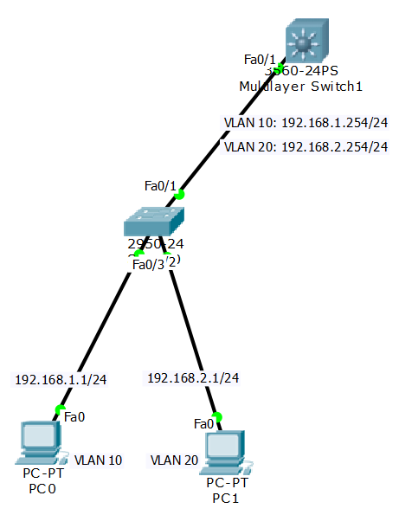

1.2 根据标识进行三层交换机和3560和二层交换机2950的配置，实现VLAN和端口绑定；
三层交换机3560完整配置命令：
SCXCORE(config-vlan)#name CS
SCXCORE(config-vlan)#vlan 20
SCXCORE(config-vlan)#name EE
SCXCORE(config-vlan)#interface vlan 10
SCXCORE(config-if)#
%LINK-5-CHANGED: Interface Vlan10, changed state to up

SCXCORE(config-if)#ip address 192.168.1.254 255.255.255.0
SCXCORE(config-if)#no shutdown
SCXCORE(config-if)#interface vlan 20
SCXCORE(config-if)#
%LINK-5-CHANGED: Interface Vlan20, changed state to up

SCXCORE(config-if)#ip address 192.168.2.254 255.255.255.0
SCXCORE(config-if)#no shutdown
SCXCORE(config-if)#exit
SCXCORE(config)#interface fa0/1
SCXCORE(config-if)#switchport trunk encapsulation dot1q
SCXCORE(config-if)#switchport mode trunk

SCXCORE(config-if)#
%LINEPROTO-5-UPDOWN: Line protocol on Interface FastEthernet0/1, changed state to down

%LINEPROTO-5-UPDOWN: Line protocol on Interface FastEthernet0/1, changed state to up

%LINEPROTO-5-UPDOWN: Line protocol on Interface Vlan10, changed state to up

%LINEPROTO-5-UPDOWN: Line protocol on Interface Vlan20, changed state to up

SCXCORE(config-if)#interface fa0/2
SCXCORE(config-if)#switchport trunk encapsulation dot1q
SCXCORE(config-if)#switchport mode trunk
SCXCORE(config-if)#exit
SCXCORE(config)#exit
SCXCORE#
%SYS-5-CONFIG_I: Configured from console by console

SCXCORE#show vlan

二层交换机2950完整配置命令：
Switch>
Switch>en
Switch#t
% Ambiguous command: "t"
Switch#conf t
Enter configuration commands, one per line. End with CNTL/Z.
Switch(config)#hostname SCXA
SCXA(config)#vlan 10
SCXA(config-vlan)#name CS
SCXA(config-vlan)#vlan 20
SCXA(config-vlan)#name EE
SCXA(config-vlan)#interface fa0/1
SCXA(config-if)#switchport mode trunk
SCXA(config-if)#interface fa0/2
SCXA(config-if)#switchport access vlan10
^
% Invalid input detected at '^' marker.

SCXA(config-if)#switchport access vlan 10
SCXA(config-if)#interface fa0/3
SCXA(config-if)#switchport access vlan 20
SCXA(config-if)#exit
SCXA(config)#exit

1.3 VLAN间可达性测试截图：
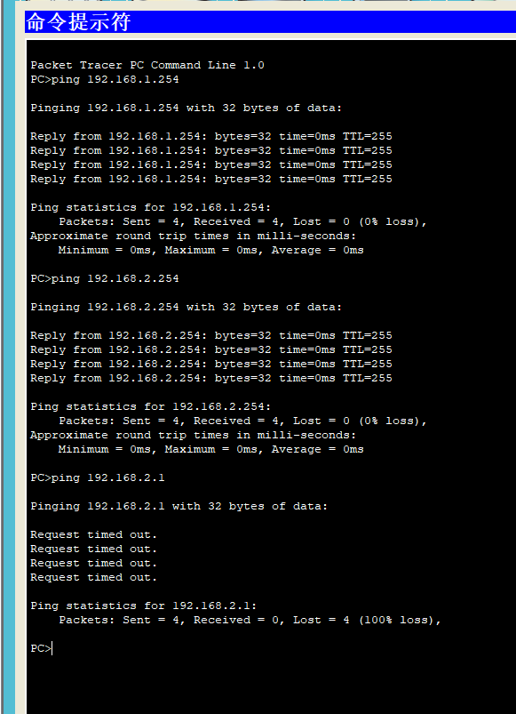

实验步骤2
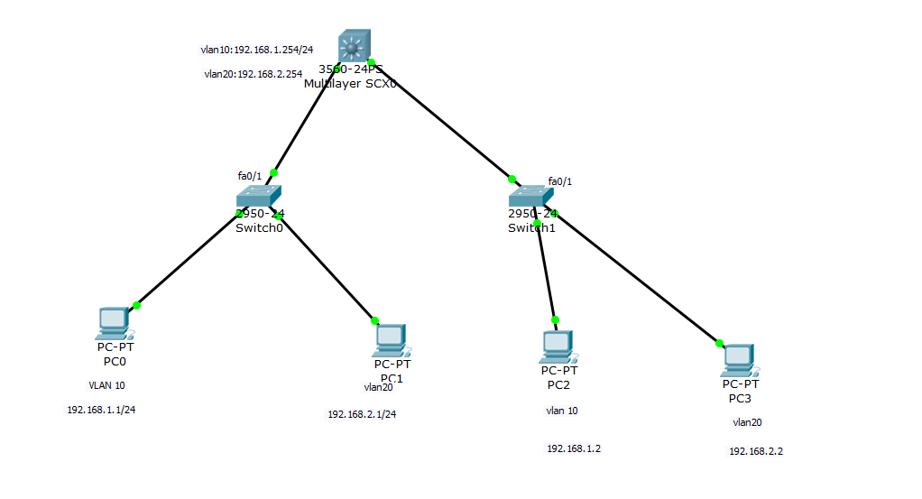
2.1 连接拓扑图并完成右侧交换机SB的配置和主机和配置
如上图所示
二层交换机2950完整配置命令：
Switch>en
Switch#conf t
Enter configuration commands, one per line. End with CNTL/Z.
Switch(config)#hostname SCXB
SCXB(config)#vlan 10
SCXB(config-vlan)#name CS
SCXB(config-vlan)#vlan 20
SCXB(config-vlan)#name EE
SCXB(config-vlan)#interface fa0/1
SCXB(config-if)#switchport mode trunk
SCXB(config-if)#interface fa0/2
SCXB(config-if)#switchport access vlan 10
SCXB(config-if)#interface fa0/3
SCXB(config-if)#switchport mode access
SCXB(config-if)#switchport access vlan 20
SCXB(config-if)#exit
SCXB(config)#exit
SCXB#
%SYS-5-CONFIG_I: Configured from console by console

SCXB#show running-config

实验步骤3
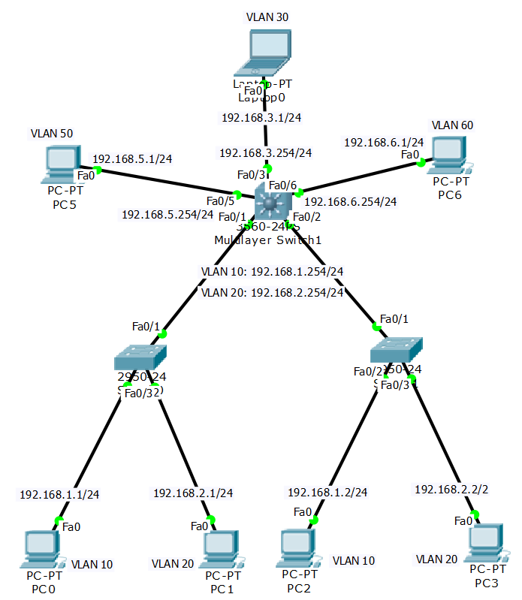

3.1 按拓扑所示，连接各设备，并进行详细标注。将自己的拓扑图截图：

3.2 配置各交换机，实现全网可连通，提供以下主机间用Ping命令测试连通性的截图：
PC0-PC6
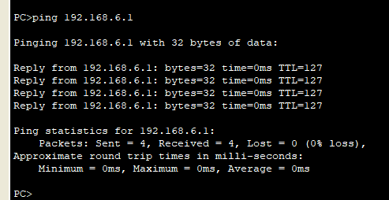
PC3-Laptop0
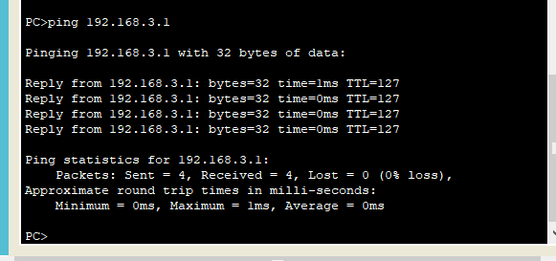
PC1-PC2
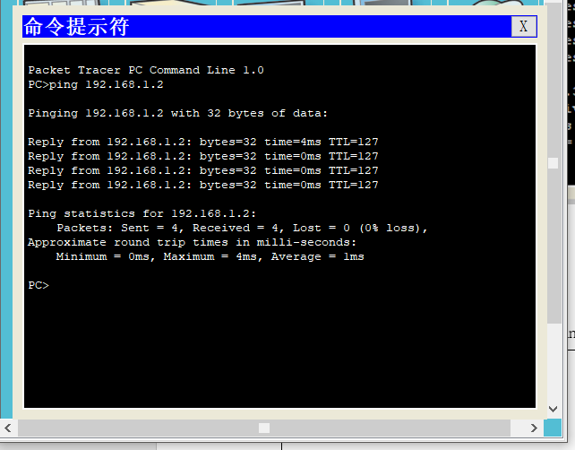

3.3 在三层交换机3560上运行show running-config命令，将结果复制到以下单元格中：
SCX#sh ru
Building configuration...

Current configuration : 1615 bytes
!
version 12.2
no service timestamps log datetime msec
no service timestamps debug datetime msec
no service password-encryption
!
hostname SCX
!
!
!
!
!
!
!
ip routing
!
!
!
!
!
!
!
!
!
!
!
!
!
!
spanning-tree mode pvst
!
!
!
!
!
!
interface FastEthernet0/1
switchport trunk encapsulation dot1q
switchport mode trunk
!
interface FastEthernet0/2
switchport trunk encapsulation dot1q
switchport mode trunk
!
interface FastEthernet0/3
no switchport
ip address 192.168.3.254 255.255.255.0
duplex auto
speed auto
!
interface FastEthernet0/4
!
interface FastEthernet0/5
no switchport
ip address 192.168.5.254 255.255.255.0
duplex auto
speed auto
!
interface FastEthernet0/6
no switchport
ip address 192.168.6.254 255.255.255.0
duplex auto
speed auto
!
interface FastEthernet0/7
!
interface FastEthernet0/8
!
interface FastEthernet0/9
!
interface FastEthernet0/10
!
interface FastEthernet0/11
!
interface FastEthernet0/12
!
interface FastEthernet0/13
!
interface FastEthernet0/14
!
interface FastEthernet0/15
!
interface FastEthernet0/16
!
interface FastEthernet0/17
!
interface FastEthernet0/18
!
interface FastEthernet0/19
!
interface FastEthernet0/20
!
interface FastEthernet0/21
!
interface FastEthernet0/22
!
interface FastEthernet0/23
!
interface FastEthernet0/24
!
interface GigabitEthernet0/1
!
interface GigabitEthernet0/2
!
interface Vlan1
no ip address
shutdown
!
interface Vlan10
ip address 192.168.1.254 255.255.255.0
!
interface Vlan20
ip address 192.168.2.254 255.255.255.0
!
ip classless
!
ip flow-export version 9
!
!
!
!
!
!
!
line con 0
!
line aux 0
!
line vty 0 4
login
!
!
!
end

3.4 在二层交换机SA上运行show running-config命令，将结果复制到以下单元格中：
SCXA#
SCXA#sh ru
Building configuration...

Current configuration : 1100 bytes
!
version 12.1
no service timestamps log datetime msec
no service timestamps debug datetime msec
no service password-encryption
!
hostname SCXA
!
!
!
spanning-tree mode pvst
!
interface FastEthernet0/1
switchport mode trunk
!
interface FastEthernet0/2
switchport access vlan 10
switchport mode access
!
interface FastEthernet0/3
switchport access vlan 20
switchport mode access
!
interface FastEthernet0/4
!
interface FastEthernet0/5
!
interface FastEthernet0/6
!
interface FastEthernet0/7
!
interface FastEthernet0/8
!
interface FastEthernet0/9
!
interface FastEthernet0/10
!
interface FastEthernet0/11
!
interface FastEthernet0/12
!
interface FastEthernet0/13
!
interface FastEthernet0/14
!
interface FastEthernet0/15
!
interface FastEthernet0/16
!
interface FastEthernet0/17
!
interface FastEthernet0/18
!
interface FastEthernet0/19
!
interface FastEthernet0/20
!
interface FastEthernet0/21
!
interface FastEthernet0/22
!
interface FastEthernet0/23
!
interface FastEthernet0/24
!
interface Vlan1
no ip address
shutdown
!
!
!
!
line con 0
!
line vty 0 4
login
line vty 5 15
login
!
!
end

3.5 在二层交换机SB上运行show running-config命令，将结果复制到以下单元格中：
SCXB>en
SCXB#sh ru
Building configuration...

Current configuration : 1100 bytes
!
version 12.1
no service timestamps log datetime msec
no service timestamps debug datetime msec
no service password-encryption
!
hostname SCXB
!
!
!
spanning-tree mode pvst
!
interface FastEthernet0/1
switchport mode trunk
!
interface FastEthernet0/2
switchport access vlan 10
switchport mode access
!
interface FastEthernet0/3
switchport access vlan 20
switchport mode access
!
interface FastEthernet0/4
!
interface FastEthernet0/5
!
interface FastEthernet0/6
!
interface FastEthernet0/7
!
interface FastEthernet0/8
!
interface FastEthernet0/9
!
interface FastEthernet0/10
!
interface FastEthernet0/11
!
interface FastEthernet0/12
!
interface FastEthernet0/13
!
interface FastEthernet0/14
!
interface FastEthernet0/15
!
interface FastEthernet0/16
!
interface FastEthernet0/17
!
interface FastEthernet0/18
!
interface FastEthernet0/19
!
interface FastEthernet0/20
!
interface FastEthernet0/21
!
interface FastEthernet0/22
!
interface FastEthernet0/23
!
interface FastEthernet0/24
!
interface Vlan1
no ip address
shutdown
!
!
!
!
line con 0
!
line vty 0 4
login
line vty 5 15
login
!
!
end

实验步骤4 （将S1交换机名改为姓名缩写）
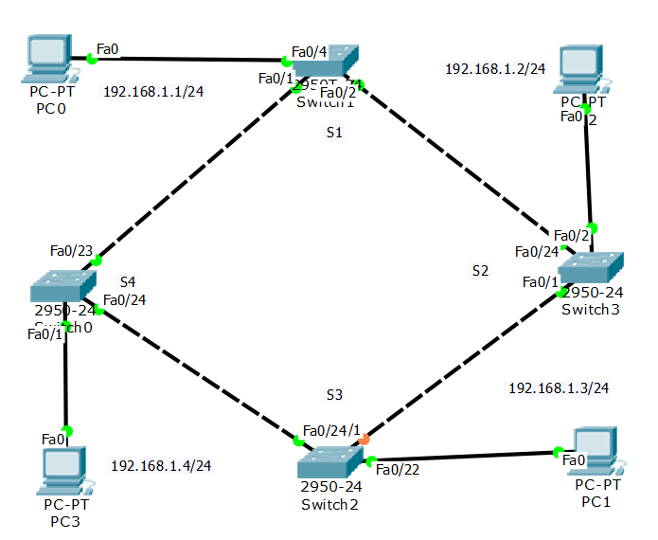
4.1 按该结构绘制拓扑图，截图如下：
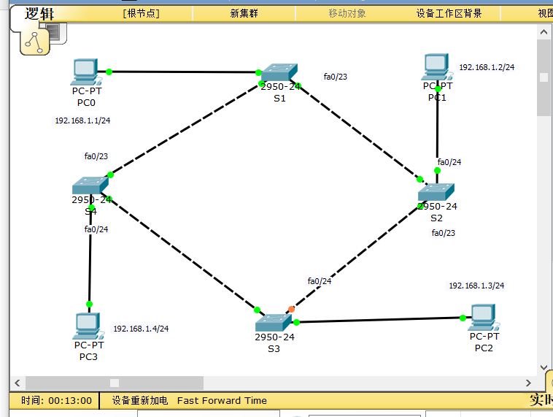

4.2 写出简单PDU从PC0-PC1的路径
PC0-S1-S2-PC1

4.3 关闭Switch2的F0/24, 写出简单PDU从PC0-PC1的路径
PC0-S1-S4-S3-S2-PC1

4.4 关闭所有交换机的STP协议，再打开Switch2的F0/24，添加一个广播包，查看当前的PDU转发情况，并截图：
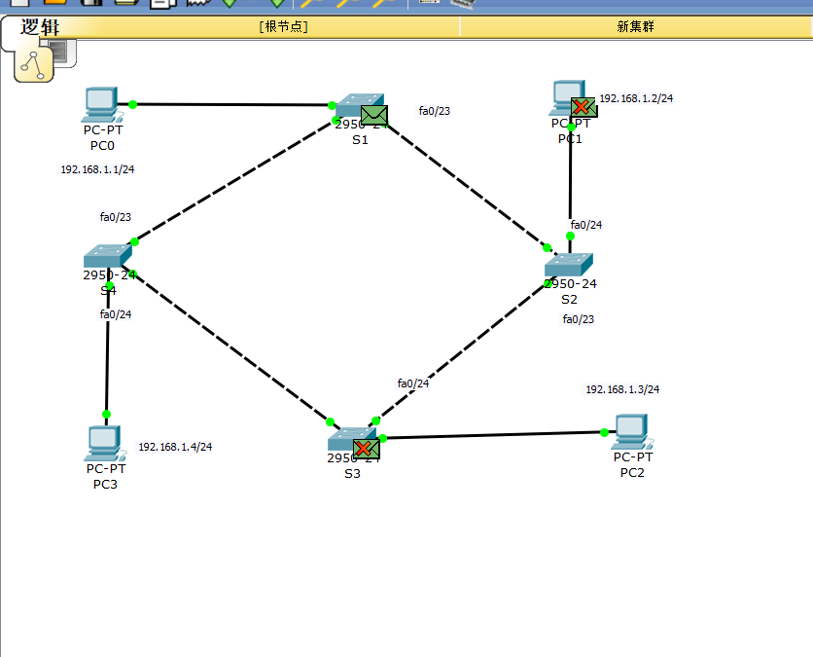

四、收获感想：记录实验感受、操作过程中遇到的困难及解决办法、遗留的问题、意见和建议等。
感觉线下课和b站教程先配合的学习方式挺好的，线下先摸索，然后有什么问题回到寝室结合视频很快就弄出来了。

